Broker

The ServiceBroker is the main component of Moleculer. It handles services, calls actions, emits events and communicates with remote nodes. You must create a ServiceBroker instance on every node.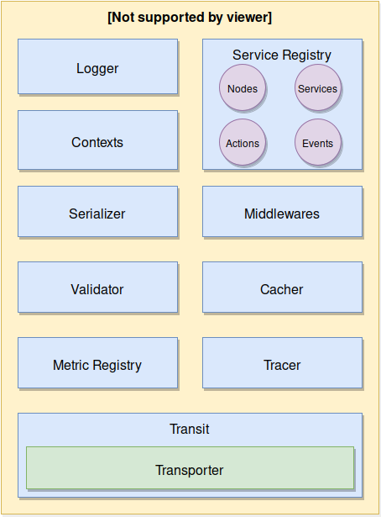
ServiceBroker

Create a ServiceBroker

Create broker with default settings:

const { ServiceBroker } = require("moleculer");
const broker = new ServiceBroker();

Create broker with custom settings:

const { ServiceBroker } = require("moleculer");
const broker = new ServiceBroker({
nodeID: "my-node"
});

Create broker with transporter to communicate with remote nodes:

const { ServiceBroker } = require("moleculer");
const broker = new ServiceBroker({
nodeID: "node-1",
transporter: "nats://localhost:4222",
logLevel: "debug",
requestTimeout: 5 * 1000
});

Metadata option

Use metadata property to store custom values. It can be useful for a custom middleware or strategy.

const broker = new ServiceBroker({
nodeID: "broker-2",
transporter: "NATS",
metadata: {
region: "eu-west1"
}
});

The metadata property can be obtained by running $node.list action.
The metadata property is transferred to other nodes.

